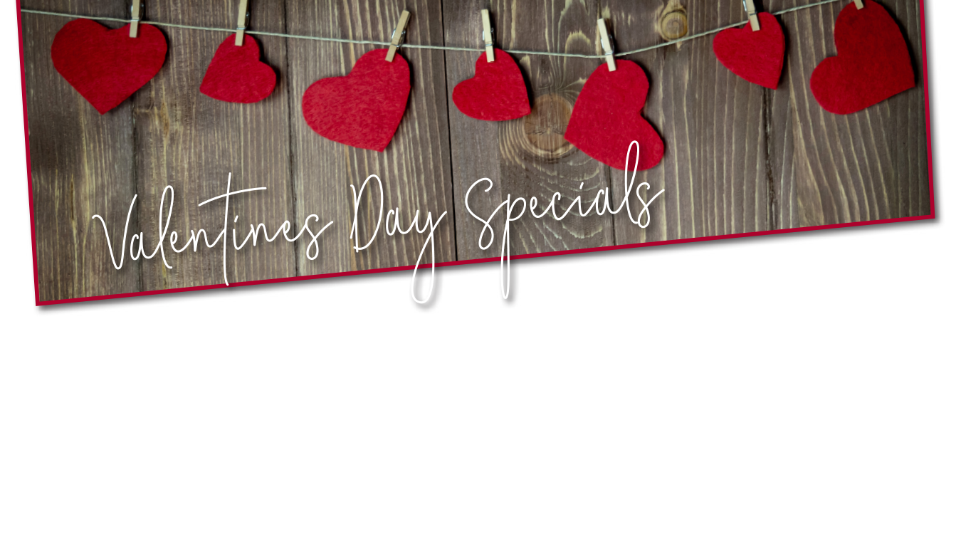
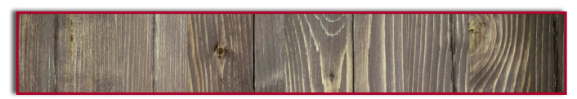
Reservations Encouraged | Website
$X Per Person
Includes Complimentary champagne and house-made chocolate truffles

Item Name
Description here, followed by price
Item Name
Description here, followed by price
Item Name
Description here, followed by price

Item Name
Description here, followed by price
Item Name
Description here, followed by price
Item Name
Description here, followed by price

MAINS

STARTERS

Item Name
Description here, followed by price
Item Name
Description here, followed by price
Item Name
Description here, followed by price
Item Name
Description here, followed by price
Item Name
Description here, followed by price
Item Name
Description here, followed by price
PHONE NUMBER HERE

ENDINGS
Item Name
Description here, followed by price
Item Name
Description here, followed by price
Item Name
Description here, followed by price

Item Name
Description here, followed by price
Item Name
Description here, followed by price
Item Name
Description here, followed by price

